# Game Design

## Concept

The concept of this game is a card based memory game. Players must match pairs of cards from two different decks. The game begins with a two sets of cards laid out on the screen all face down, one set of radiation cards and another set of protection cards. The player clicks on a card from the first set to turn it over revealing its symbol and then clicks on another card from the second set to do the same. If the type of protection matches with the type of radiation then the cards are removed and the player scores points. Bonus points can be scored by revealing a specific matching pair shown at the top of the screen at certain times.

## Objectives and Scoring

The objective of the game is to clear all of the cards from the playing area before the time limit expires. Players will score 5 points for every pair of cards they correctly match, 20 bonus points can be scored for matching the cards indicated at the top of the screen within 15 seconds. If the player completes the level before the time has run out then they will also score 1 point for every second left on the clock.

## Difficulty

There will be three different levels of difficulty for the game; Easy, Medium and Hard. The differences between them shall be as follows:

Easy – 10 pairs of cards to match, descriptions on cards, normal scoring, 2 minute time limit.

Medium – 15 pairs of cards to match, no descriptions, double scoring, 1.5 minute time limit.

Hard – 20 pairs of cards to match, no descriptions, triple scoring, 1 minute time limit.

## Controls

The main method of controlling the game will be via the mouse. Players will use the mouse to navigate around menus and will also use it to select cards. The keyboard will be used for entering the players name into the high score table, with the arrow keys also available to navigate menus

Mouse – Navigate menus, left click to select card/menu item

Esc – Go back

Arrow Keys – Navigate menus/highlight card

Enter – Select menu item/card

## User Interface

The main game screen will consist of the following items:

* The main play area – the area where the cards are displayed and interacted with
* Score – this will be displayed in the top right hand corner of the screen
* Time – the remaining time will be displayed in the top right below the score
* Bonus indicator – the card worth bonus points will be displayed in the right hand side of the screen in the centre for as long as the bonus is active for.

## Sketches

The following screens will be presented to the player when they begin the game:

* Title and Description Screen – the title of the game and a short description of what the player has to do, including a list of all the cards the player will see in the game
* Game play screen – the game
* High score table – a chance for the player to enter their score into the table and compare it to other players

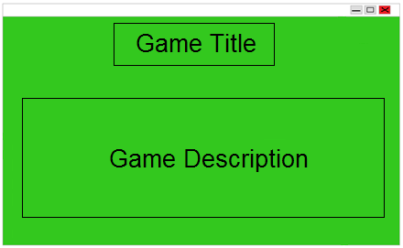Some initial sketches of what the game will look like are included below:

Game title and description screen

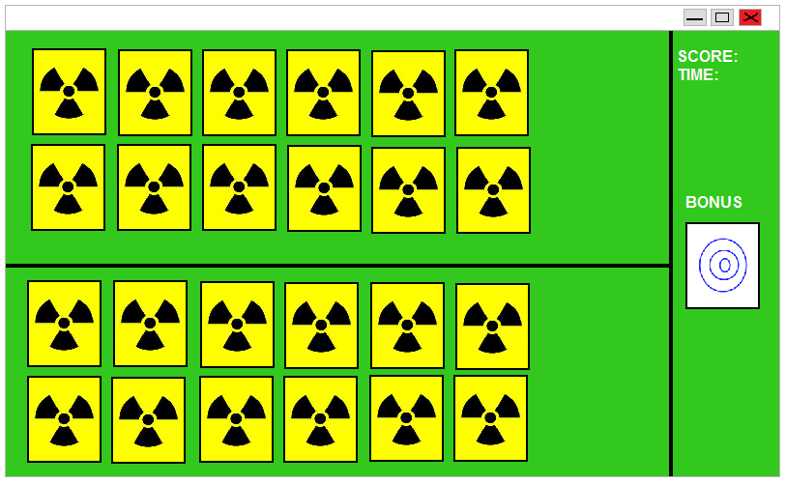

Game play screen, showing play area, score, time and bonus card